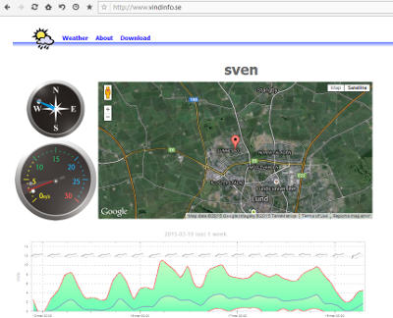
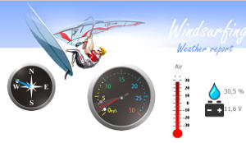
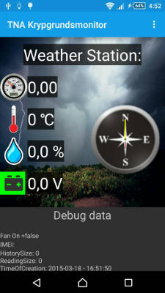
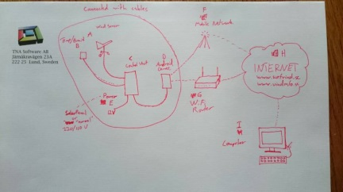

WindMaster
-Your own weather station
Publish local wind speed, direction, temperature and humidity directly to your Android phone or tablet and online.
Picture 1: Your wind and weather information can be displayed in attractive graphical format on our site www.vindinfo.se
Picture 2: Your sensors are also viewable at our specialist windsurfer weather site www.surfvind.se
Perfect for members of sailing clubs, windsurfers and, model plane flying clubs.
Ideal for your personal use to monitor conditions in a remote location such as your holiday home, yacht, caravan or any other place of interest.
Picture 3: Your Android phone or tablet acts as a weather console when it is connected to your WindMaster system.
The advanced WindMaster system sends weather measurements from its sensors to any Android device, which can then use your own WiFi router or the cellular network (3G, 4G etc) to access Internet and publish it online.
Have a wall mounted display console using a cheap Android tablet, or use a spare smartphone.
All data is updated instantly. Anybody can view the information online.

What you get in your WindMaster package
-The Davis 7611 anemometer and 15m cable – measures wind speed and direction.
-Temperature and humidity sensors x 2.
-Control unit with standard USB cable to attach your Android device.
-App for your Android device.
The anemometer was selected after testing several high end and budget options. This Davis 7611 instrument combines rugged construction with precision machine crafting and hand balanced fine tuning. It has been known to withstand winds of 280 kph but senses and responds to whispers of breeze. It operates in extremes of heat or cold and is designed to repel water that can cause icing.
It has sensors for wind speed as well as wind direction and its steel ball bearings are sealed for long life trouble free usage.
A 15 metre cable, supplied with the anemometer, connects it to the control unit, which should be housed nearby. The control unit runs on 12V DC or 220V AC and could be powered by a solar panel.
Temperature and humidity sensors are based on two of the renowned Chip Cap 2 processors made by General Electric. This versatile and reliable sensor is used in hospitals, climate control in vehicles and is perfect for weather stations. One can be positioned outside for weather measurement and can be connected by a cable to the control unit. The second is mounted on the control unit to measure your indoor climate (or wherever you decide to place the control unit).
Finally, the App that interrogates the data can be downloaded from the GooglePlay app store to your own Android device. You connect your device to the control unit using the standard USB cable that comes with your package (Bluetooth is under development). The app displays the data on your device and sends it to the global website using your own data carrier (mobile) network or your own WiFi router.
The WindMaster package has been carefully assembled with the best available components to provide you with ease of assembly and a long and trouble-free life
Unlike other wind and weather products, WindMaster does not require a dedicated computer with a wired Internet connection, which would be an added expense costing more than the WindMaster, and which would need to be constantly running. Just assemble the package, attach it to your phone or tablet and obtain immediate measurement data!
Your weather data will automatically be displayed on our websites www.vindinfo.se and www.surfvind.se (for windsurfers) where anybody can view your WindMaster information.
You can also include the information on your own site using the iFrames technique, which displays data from our site on your own webpage.

Swedish Manufactured: The product was developed in Sweden.
Price: 4990 SEK including VAT, Android device not included.
Contact: Thomas Hermansson, TNA Software AB, Jakthornsgränden 22, 226 52 Lund, Sweden, Mail:thomas@tna.se Tel: 0702-313255
The first 5 customers get a 50% discount Total price is 2500 SEK
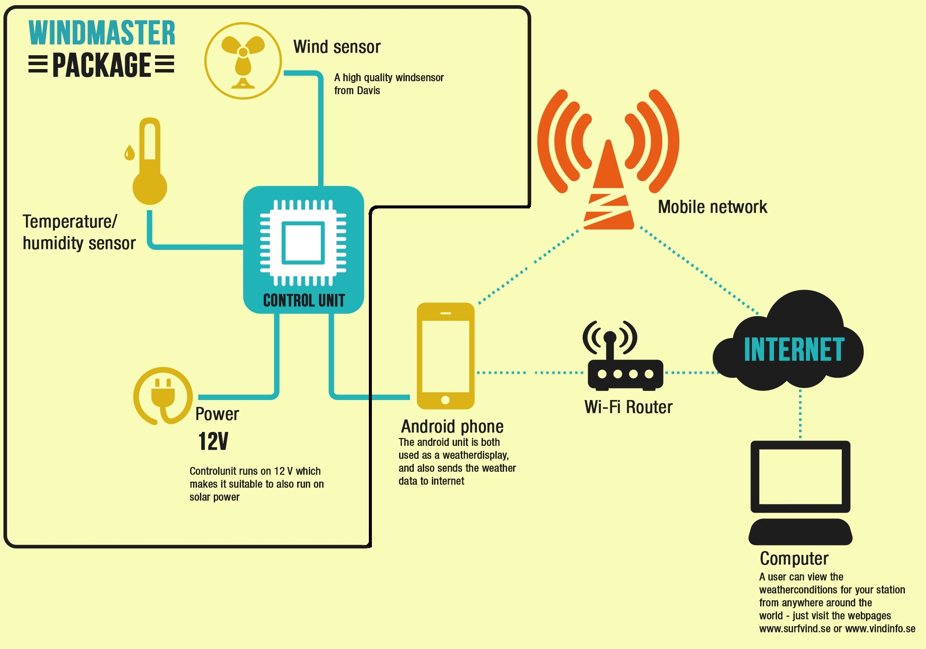
Picture 4: Details of how all of the components of the WindMaster system interconnect

